Assignment – 06
Q1. An assembly program to add two 8-bit Hexadecimal numbers and store result in decimal form only which will be a 16-bits number.
Code:
MVI A,45H;
MVI B,38H;
ADD B;
DAA;
STA 2002H;
MVI A,00H;
ADC A;
STA 2003H;
HLT;
Listing:
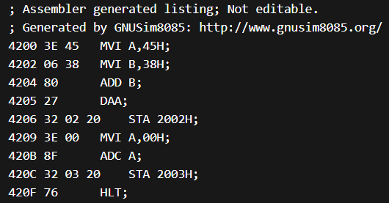
Q2. An assembly program to multiply two numbers.
Code: MVI B,05H;
MVI C,06H;
MVI A,00H;
LOOP: ADD C;
DCR B;
JNZ LOOP;
HLT;
Listing:
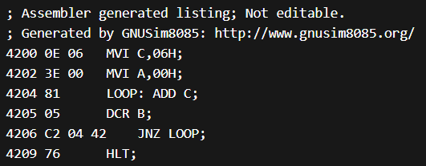
Q3. Program to find square of 8-bit number.
Code:
MVI B,05H;
MOV C,B;
MVI A,00H;
LOOP: ADD C;
DCR B;
JNZ LOOP;
HLT;
Listing:
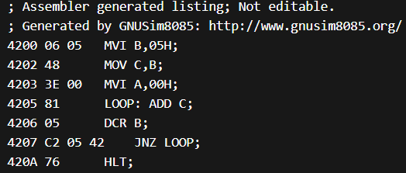
Q4. Program to find sum of digit of an 8-bit number.
Code:
MVI A,45H;
MOV B,A;
ANI 0FH;
MOV C,A;
MOV A,B;
ANI 0F0H;
MVI D,04H;
LOOP: RRC;
DCR D;
JNZ LOOP;
ADD C;
HLT;
Listing:
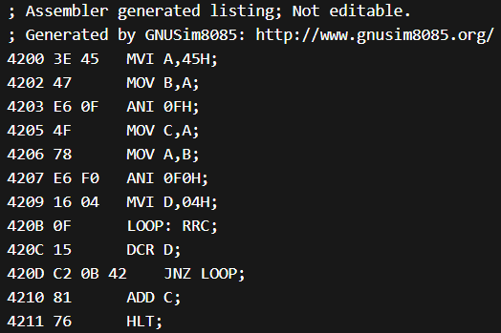
Q5. An assembly program to find the largest number from the given array.
Code:
LXI H,2000H;
MOV C,M;
INX H;
MOV A,M;
DCR C;
LOOP: INX H;
CMP M;
JC UPDATE;
NEXT: DCR C;
JNZ LOOP;
STA 2006H;
HLT;
UPDATE: MOV A,M;
JMP NEXT;
Listing:
